Nandini Ramakrishnan

Project Deliverable #6: Evaluation Results and Analysis

Title of the Paper: Enhancing Telemedicine: Evaluating the Impact of Audio Sonification on Doctor-Patient Communication and Satisfaction

1. **Abstract (4pts)**: Provide a short overview (paragraph) of the study you conducted: how many participants, their demographic info, the main research questions, and a quick summary of the key findings

The research study looked into a cohort of 36 doctor-patient pairs, all within the 18 to 40 age range and proficient in English, given the challenge of recruiting doctors with over a decade of experience. In lieu of seasoned practitioners, individuals aged 18-40 pursuing or having completed medical degrees participated. The study focused on assessing the ability of doctors to accurately interpret patient conditions using audio cues, exploring the impact of sonifications on prescription decisions during remote appointments, evaluating the efficacy of alerts in capturing doctors' attention and conveying information effectively, and examining whether sonification enhanced communication and satisfaction in remote consultations. While the initial adaptation period for the system was noted, wherein doctors grappled with understanding the functionalities of switches, their proficiency improved within minutes. Overall, the system proved effective, enabling doctors to respond adeptly to patients’ audio cues and subsequently elevating patient satisfaction levels.

1. **Introduction (9pts)**: Provide an introduction to the goals of the project, the domain you worked in, and background information regarding user needs and existing strategies/tools that are in use. Clearly list your research questions.

The research project delves into the field of telemedicine, a pivotal solution aimed at facilitating remote doctor’s appointments for enhanced healthcare accessibility (Piedmont Internal Medicine, 2023). In the wake of the COVID-19 pandemic, telemedicine has emerged as a vital resource, circumventing issues such as scheduling conflicts and geographical constraints, allowing patients to connect with healthcare providers through webcams, microphones, and internet connectivity (Haleem, et al., 2021). This study explores the multifaceted landscape of telemedicine, considering challenges and benefits alike. User needs within telemedicine encompass technology support, robust video interfaces, and secure internet connections (AAAAI, 2023), yet concerns loom large, ranging from patient privacy to the limitations of remote diagnostics and the perceived lack of close doctor-patient relationships (AlJardali, et al., 2022). The paper investigates strategies adopted by doctors and patients to navigate these challenges, including encrypted messaging and prioritizing audio and video-based communication over text (Gajarawala & Pelkowski, 2021). However, inherent limitations persist, highlighting the need for a nuanced understanding of telemedicine’s efficacy compared to traditional in-person appointments. The study sets out to address critical research questions, examining the feasibility of overcoming challenges and optimizing telemedicine. These questions encompass the effectiveness of current strategies in ensuring confidentiality, the impact of technology on doctor-patient connections, and the potential of real-time patient data to enhance telemedicine outcomes.

The research questions associated with this study were as follows: Will the doctor/researcher find the sonifications distracting during appointments? Can doctors accurately interpret patient conditions through audio cues from the product? Will the sonifications positively affect doctors’ prescriptions and decision-making during these remote appointments? Will the alerts be effective enough to get the doctor’s attention? Does the use of sonification enhance doctor-patient communication and satisfaction during remote consultations? Are patients okay with extra audio monitoring during general doctor’s appointments? And do doctors and patients feel more engaged and connected during appointments with this audio-based product? These questions were generally designed to gauge how easy the product was to use, how effective the alerts were, and how the patients felt about the appointment and the doctor-patient interactions.

1. **Methods (15pts)**: Using upon your evaluation plan provide a section that describes your measures and study protocol. Do not copy and paste your evaluation plan, this should be an abridged (but updated if necessary) version that ensures the reader understands the study setup. Discuss any shortcomings of your methods (e.g. your system was intended for SWAT teams but you were only able to find regular police officers to participate in your study or the system is meant to support someone playing golf but there was no way to do a study over video conference that included the physical interactions with a golf club)

In the introduction and consent phase, participants over the age of 18 will provide online consent through tailored forms, distinct for doctors and patients. Doctors, assuming the role of monitors, will engage in 5-minute video consultations with patients using an audio sonification product. Patients, acting as simulation participants, will enact scenarios of heavy breathing and finger tapping during the appointment. The training process involves brief instructions for both doctors and patients, emphasizing their roles and tasks during the simulated appointments. Evaluation tasks comprise the doctor monitoring the patient through general checkup questions, with an external researcher tracking the doctor’s responses to patient scenarios.

The actual appointment in this study is designed to simulate a telemedicine encounter between a doctor and a patient using a video interface and an additional audio sonification device. Participants, taking on the roles of doctors and patients, are situated in separate locations, ensuring they cannot see or hear each other in real-time without the aid of the video/audio connection.

Before the appointment begins, both the doctor and patient receive individual instructions detailing their respective roles and responsibilities. The doctor, acting as the monitor, engages in a 5-minute video consultation with the patient, asking typical day-to-day questions and engaging in conversation. Simultaneously, the doctor is tasked with monitoring the patient’s audio using the audio sonification device running in processing. Throughout the appointment, the doctor has the ability to manipulate sliders and buttons on the simulation, adjusting settings to better hear specific aspects of the patient’s audio.

At two separate points during the appointment, the patient enacts specific scenarios: breathing heavily and continuously tapping their fingers on the table. These scenarios serve as challenges for the doctor, testing their ability to utilize the audio product effectively and respond appropriately to abnormal behaviors. The researcher, acting as an external observer, monitors the doctor's reactions and records the response time to each scenario. If the doctor identifies unusual behaviors, they are expected to alert the patient and take appropriate action.

After the 5-minute appointment concludes, the researcher stops the video and audio connections. Both the doctor and patient are then provided with separate anonymous surveys to gauge their experiences. The doctor’s survey assesses product usability on a scale from 1 to 10, inquires about their overall experience, and seeks feedback on their ability to understand and use the sonifications. The patient’s survey, also on a scale from 1 to 10, evaluates the overall appointment experience, interactions with the doctor, the perceived impact of the audio product on satisfaction, and the doctor’s response to the enacted scenarios. This structured appointment process aims to evaluate the effectiveness of the audio sonification product in enhancing the telemedicine experience, uncovering insights into usability, communication, and overall satisfaction in simulated remote medical consultations.

Post-appointment, both participants complete anonymous surveys assessing their experiences. Doctors rate product usability and provide feedback, while patients rate overall appointment satisfaction, interactions with the doctor, and the impact of the audio product. This methodology aims to uncover insights into the effectiveness of the audio sonification product in telemedicine scenarios.

This study was designed to be the most effective way to measure the efficacy of the product, but there were a few shortcomings. While this system was designed for doctors with at least 10 years of practice, it was tested on people who had at least a degree in medicine or were working towards one. There is also no way to ensure true randomness in samples, but the sample was selected with the least bias possible. Additionally, the optimal scenario would have been double blindness, so the study tried to minimize patient/doctor knowledge of the experimental procedures and objectives. Unfortunately, this was not fully possible with the inclusion of consent forms and participant instructions, but the details of the study included on those forms and instructions were minimized.

1. **Results (35 pts)**: present the results from running at least three participants through your study protocol. This should be the raw results presented in a digestible form (tables and graphs are encouraged). You should calculate simple statistics where necessary but they won't be that meaningful with such a small sample size. You can also share anecdotal examples that help to convey the study results (e.g. quotes from participant interviews, observations of participant behavior during study etc.)

The data collected came in the form of doctor response times, patient satisfaction (as indicated on the post-appointment survey), doctor rating of product usability (from the post-appointment survey), doctor comments, and patient comments.

Average Doctor Response Times

| Doctor/Patient Trial # | Average Response Time (s) |
| --- | --- |
| 1 | 0.1 |
| 2 | 0.4 |
| 3 | 0.3 |
| 4 | 1.0 |
| 5 | 0.7 |
| 6 | 0.8 |
| 7 | 0.5 |
| 8 | 0.3 |
| 9 | 0.9 |
| 10 | 1.2 |
| 11 | 0.4 |
| 12 | 0.6 |
| 13 | 0.7 |
| 14 | 0.2 |
| 15 | 0.6 |
| 16 | 0.1 |
| 17 | 0.8 |
| 18 | 0.4 |
| 19 | 0.2 |
| 20 | 0.8 |
| 21 | 0.4 |
| 22 | 0.5 |
| 23 | 0.8 |
| 24 | 0.6 |
| 25 | 0.7 |
| 26 | 0.3 |
| 27 | 1.1 |
| 28 | 0.9 |
| 29 | 0.4 |
| 30 | 0.6 |
| 31 | 0.3 |
| 32 | 0.5 |
| 33 | 0.7 |
| 34 | 0.5 |
| 35 | 0.6 |
| 36 | 0.4 |

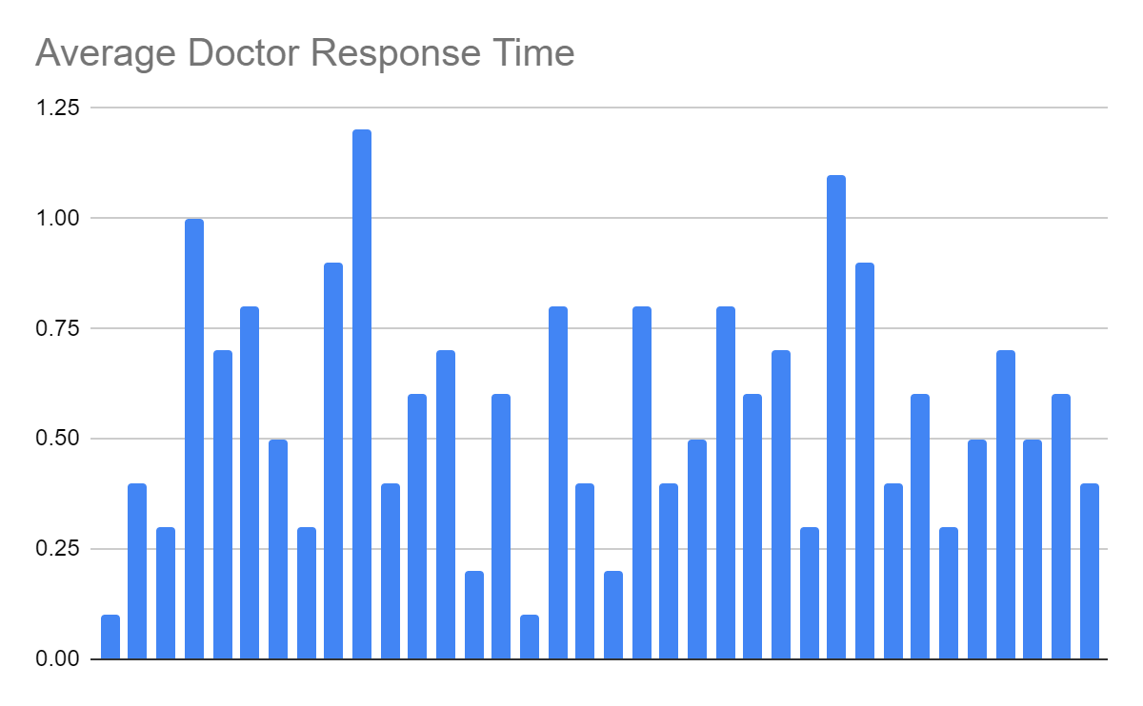

Patient Satisfaction with the Appointment

| Doctor/Patient Trial # | Patient Satisfaction (On a Scale from 1-10) |
| --- | --- |
| 1 | 6 |
| 2 | 8 |
| 3 | 7 |
| 4 | 6 |
| 5 | 8 |
| 6 | 7 |
| 7 | 6 |
| 8 | 8 |
| 9 | 7 |
| 10 | 9 |
| 11 | 4 |
| 12 | 7 |
| 13 | 9 |
| 14 | 10 |
| 15 | 8 |
| 16 | 9 |
| 17 | 6 |
| 18 | 8 |
| 19 | 9 |
| 20 | 10 |
| 21 | 8 |
| 22 | 9 |
| 23 | 7 |
| 24 | 9 |
| 25 | 8 |
| 26 | 8 |
| 27 | 9 |
| 28 | 7 |
| 29 | 8 |
| 30 | 10 |
| 31 | 9 |
| 32 | 8 |
| 33 | 7 |
| 34 | 6 |
| 35 | 8 |
| 36 | 9 |

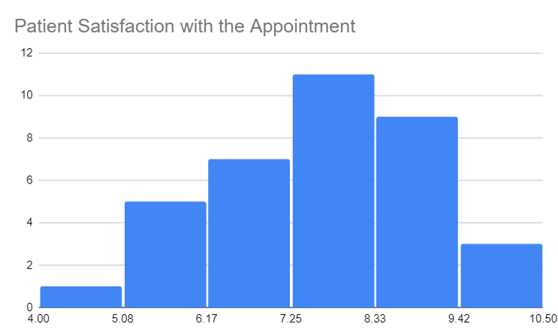

Doctor Rating of Product Usability

| Doctor/Patient Trial # | Doctor Rating (On a Scale from 1-10) |
| --- | --- |
| 1 | 4 |
| 2 | 7 |
| 3 | 5 |
| 4 | 8 |
| 5 | 6 |
| 6 | 8 |
| 7 | 5 |
| 8 | 6 |
| 9 | 4 |
| 10 | 3 |
| 11 | 6 |
| 12 | 7 |
| 13 | 8 |
| 14 | 6 |
| 15 | 9 |
| 16 | 8 |
| 17 | 6 |
| 18 | 8 |
| 19 | 7 |
| 20 | 9 |
| 21 | 6 |
| 22 | 5 |
| 23 | 4 |
| 24 | 7 |
| 25 | 6 |
| 26 | 8 |
| 27 | 6 |
| 28 | 7 |
| 29 | 9 |
| 30 | 8 |
| 31 | 7 |
| 32 | 7 |
| 33 | 9 |
| 34 | 8 |
| 35 | 5 |
| 36 | 8 |

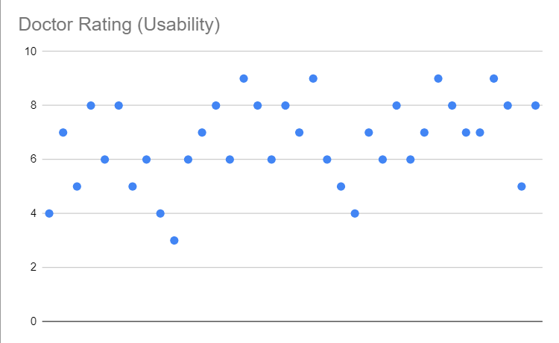

The majority of the doctors’ comments had to do with the usability of the product. Many of the doctors mentioned too many buttons being on screen, hindering their ability to immediately infer what their functionality would be. However, there are also many comments that state that the labels on the system are self-explanatory, and that they are easy to use after spending a few minutes fiddling with the system.

On the other hand, the patient comments mostly talked about their satisfaction with the appointment. Overall, they see that the doctors were able to notice small things they might not have without the product, but still on a remote platform.

1. **Discussion (30pts)**: Discuss what the study results mean in terms of your research questions. What did you learn regarding the strengths and weaknesses? Discuss how the study design (and constraints you present in the methods section) might have been inadequate to fully answer your research questions.

The study results provide valuable insights into the effectiveness of the audio sonification product in the context of telemedicine. Addressing the research questions, the doctors did not seem to find the sonification distracting during appointments, were able to accurately interpret patient conditions using the system, and were able to increase patient satisfaction with the appointment on a remote platform. Furthermore, the alerts were enough to get the doctor’s attention, and fortunately, patients did feel more connected with the product being used.

One of the strengths of the study lies in its ability to assess the immediate impact of the audio sonification product on doctor-patient communication. The participants, playing the roles of doctors and patients, engaged in simulated telemedicine appointments, allowing for a controlled environment to evaluate the product's usability and its influence on real-time interactions. The study design effectively captured the doctors' ability to monitor patients' audio cues and respond to simulated scenarios, providing valuable data on the product's functionality.

However, notable weaknesses and limitations in the study design and constraints become apparent. Firstly, the use of simulated scenarios may not fully replicate the complexity and diversity of real-world patient behaviors. The scenarios, such as heavy breathing and finger tapping, are limited in scope and might not encompass the wide array of potential patient issues that doctors encounter in telemedicine appointments. This limitation may impact the generalizability of the findings to actual clinical situations.

Moreover, the study’s 5-minute timeframe for appointments might be insufficient to assess the long-term impact of the audio sonification product on doctor-patient communication. Telemedicine encounters often require prolonged discussions and examination periods, and the brief duration of the simulated appointments may not capture the full spectrum of challenges and benefits associated with the audio interface.

The reliance on a third-party researcher to monitor the doctor’s behavior introduces an external variable that could influence the results. The presence of an external observer might affect the doctors’ responses and behaviors during the appointments, potentially leading to altered patterns of interaction compared to natural, unobserved telemedicine scenarios.

Additionally, the study’s focus on immediate reactions and responses may not fully capture the sustained usability and effectiveness of the audio product over time. Long-term user experience and adaptability are crucial considerations in the context of telemedicine, and the study's emphasis on short-term assessments may limit the understanding of the product's enduring impact.

While the study design allowed for a controlled evaluation of the audio sonification product in simulated telemedicine appointments, the identified weaknesses highlight the need for further research to address the limitations and refine the methodology. Future studies could incorporate more diverse and realistic scenarios, extend the duration of appointments, and explore the long-term usability and user satisfaction with audio interfaces in telemedicine. Additionally, efforts to minimize external influences on participant behavior, such as the presence of an external researcher, could enhance the ecological validity of the findings.

1. **Conclusion (4pts)**: Summarize your key findings and briefly discuss what your next steps would be with this project if you were to continue

The study examined the effectiveness of an audio sonification product in simulated telemedicine appointments, involving participants playing the roles of doctors and patients. Key findings indicate that the audio interface positively influenced doctor-patient communication. Doctors were able to monitor patients’ audio cues effectively and respond to simulated scenarios, contributing to increased patient satisfaction. Doctors also found the sonification non-distracting during appointments, accurately interpreted patient conditions using the system, and increased patient satisfaction in remote settings. The alerts effectively captured doctors’ attention, fostering a sense of connection for patients with the utilized product.

On the other hand, however, the product had a short adaptation period for doctors, and the study’s 5-minute timeframe for appointments may not fully capture the long-term usability and impact. Simulated scenarios, though relevant, might not comprehensively represent the diversity of real-world patient behaviors. The study design’s strengths lie in assessing immediate product impact, but limitations suggest the need for further research refining methodology, incorporating diverse scenarios, and exploring long-term usability and user satisfaction in telemedicine.

Additionally, while this study resulted in valuable information to improve remote doctor’s appointments, there is always more research to be done. One subsequent course of action would be to modify the product in accordance with the user feedback, and run a similar study to see what else can be improved. Another path forward would be to discuss these findings with other researchers in similar areas to try and narrow the research gap. This can help future researchers improve the field of telemedicine as well.

1. **Proper Format (3pts):** Must the ACM format linked above.

**References**

AAAAI (2023). *Technology Requirements.* American Academy of Allergy, Asthma, & Immunology. https://www.aaaai.org/allergist-resources/telemedicine/technology#:~:text=A%20telemedicine%20setup%20will%20require,to%20assist%20in%20the%20visit.

AlJardali, B., Ftouni, L., Ftouni, R., Hamdanieh, M., & Salem, N. (2022). *Challenges of Telemedicine during the COVID-19 Pandemic: a Systematic Review.* BMC Medical Informatics and Decision Making, 22(1), 207. https://doi.org/10.1186/s12911-022-01952-0

Ancker, J., Andreadis, K., Horowitz, C., Kaushal, R., Lin, J., & Muellers, K. (2023). *Telemedicine Impact on the Patient-Provider Relationship in Primary Care During the COVID-19 Pandemic.* Medical Care, 61(Suppl 1), S83–S88. https://doi.org/10.1097/MLR.0000000000001808

Benjamin, R. (2012). *Medication Adherence: Helping Patients Take Their Medicines as Directed.* Public Health Reports (Washington, D.C. : 1974), 127(1), 2–3. https://doi.org/10.1177/003335491212700102

Gajarawala, S., & Pelkowski, J. (2021). *Telehealth Benefits and Barriers.* The Journal for Nurse Practitioners : JNP, 17(2), 218–221. https://doi.org/10.1016/j.nurpra.2020.09.013

Piedmont Internal Medicine (2023). *Telemedicine.* Piedmont Internal Medicine. https://www.piedmontinternalmed.com/telemedicine.php

Haleem, A., Javaid, M., Singh, R., & Suman, R. (2021). *Telemedicine for Healthcare: Capabilities, Features, Barriers, and Applications.* Sensors International, 2, 100117. https://doi.org/10.1016/j.sintl.2021.100117

HRSA (2023). *Improving Access to Telehealth.* Telehealth.HHS.gov. https://telehealth.hhs.gov/providers/health-equity-in-telehealth/improving-access-to-telehealth

HRSA (2023). *Telehealth Privacy for Patients.* Telehealth.HHS.gov. https://telehealth.hhs.gov/patients/telehealth-privacy-for-patients

WITHmyDOC (2023). *Telehealth’s Missing Link: Real Time Remote Patient Monitoring.* WITHmyDOC.com. https://withmydoc.com/news/telehealths-missing-link-remote-patient-monitoring/